**4.2 HOME PAGE OF MEDICAL CLINIC**

* Home page consist of login for users who already a member
* Add the details of the different user details here and product details

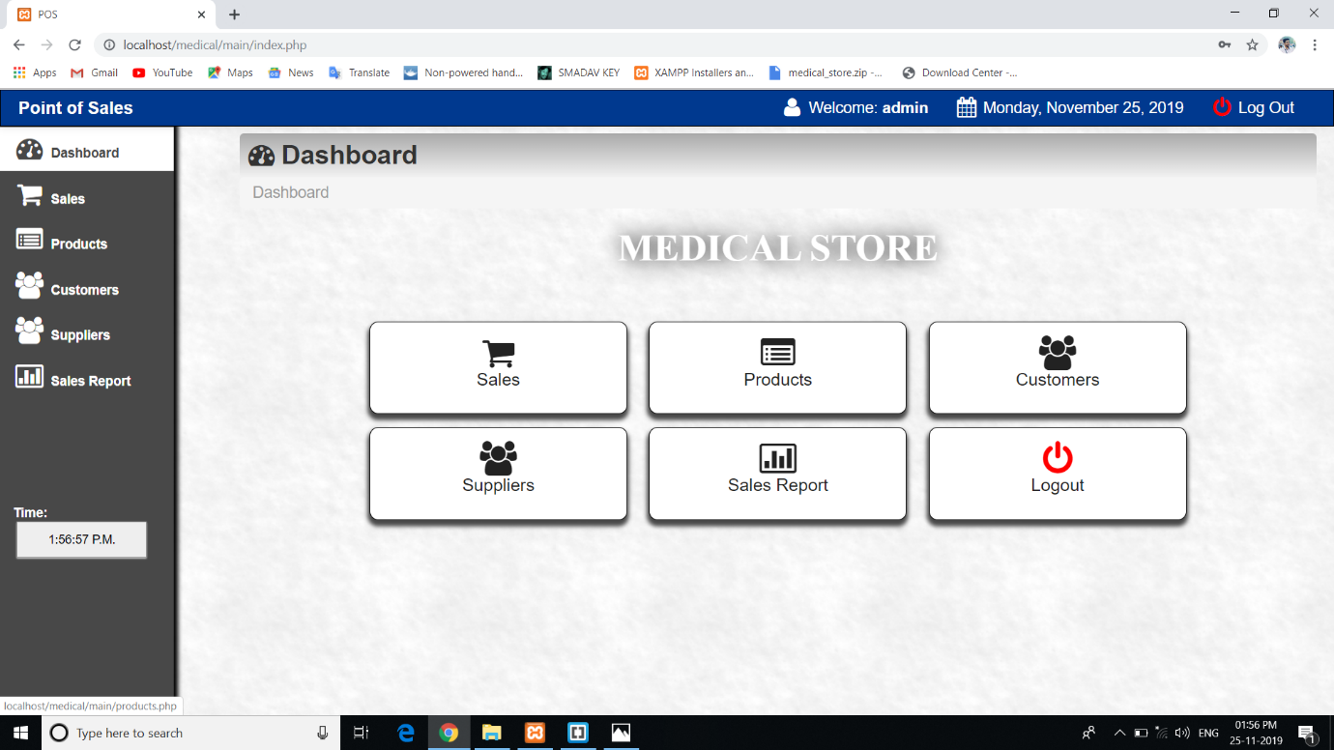

# **Fig 4.2:Home page of Medical Clinic Management**